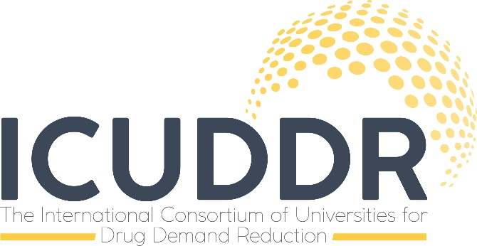
University Request Form for Consultation
ICUDDR Main Goals
Network Development
Develop a network of universities engaged in the design and implementation of academic curricula and programs in addiction prevention and treatment studies.
Research
Advance applied research in addiction prevention and treatment.
Education
Engage students and addiction professionals in academic and continuing education programs in addiction studies, and promote career opportunities in prevention and treatment
University-Community Outreach
Enhance partnerships among university programs in addiction studies, addiction professionals, and the addiction science research and practice communities.
Advocacy
- Provide advocacy within universities for the development of academic programs in addiction studies.
- Advocate for policy change to support the development of academic programs in addiction studies, and to enhance addiction prevention and treatment services.
- Develop and advocate for guidelines and standards for academic programs in addiction studies.

University Consultation
We can provide free consultation to your University in alignment with the goals of the organization. Some examples of what we can provide include, but are not limited to:
- Curriculum development and/or sequencing of academic coursework related to undergraduate study programs, master’s programs, Ph.D. programs on alcohol and drug demand reduction.
- Establishing practica and field experience coursework in addiction treatment and behavioral health services.
- Specific topics related to addiction studies (co-occurring disorders, criminal justice interventions for persons who have substance use disorders and co-occurring disorders, diversion programs in the criminal justice system such as drug courts, screening and assessment for substance use disorders, mental disorders/co-occurring mental disorders, the neuroscience of addictions, for example). We can provide guest speakers for your courses or help with content development for specific topics within a course.
The assistance can be for something as broad as developing a new addiction treatment degree program, or as narrow as content for a particular lecture.

Information from Requesting Institution
Contact Information
University/Institute of Higher Learning name: _______________________________________ ____________________________________________________________________________
Lead person at the requesting institution, position title, and credentials: __________________________________________________________________________________________________________________________________________________________
Name of institutional unit (e.g., college/department/program): _____________________________________________________________________________
_____________________________________________________________________________
E-mail address for lead person: ___________________________________________________
Phone number for lead person: ___________________________________________________
Notes on what consultation, assistance, and support you need from ICUDDR: ______________
_____________________________________________________________________________
_____________________________________________________________________________
_____________________________________________________________________________

